**WEB PHISHING DETECTION**

**INTRODUCTION**

* 1. **PROJECT OVERVIEW**

This project describes the machine learning based Over the last decade, many cyber-attacks start with a poisoned link in a seemingly harmless email. When you click on the link, it could be a phishing or malicious site. Phishing websites try to hook Internet surfers into revealing their sensitive information including credentials, bank account, and other personal information and malicious sites try to install malware onto your devices. These new, short-lived phishing URLs can easily bypass signature-based detectors. To combat this problem, researchers have also used machine learning methods to detect phishing websites. Nevertheless, there is still no definitive solution with machine learning or another approach.

The main objective of the web phising process consists of

1. To create a dataset and apply necessary preprocessing followed by feature selection.
2. To apply various machine learning models and compare them based on different metrics.
3. To run all the algorithms in the selected cloud platform using IBM Cloud's AutoAI feature to validate the choose obtained previously.
4. To implement and deploy the selected machine learning model onto a cloud-based platform.
5. To predict the probability of a website being legitimate or phishing based on the URL of the website.
   1. **PURPOSE**

The main purpose of the web phising project Phishing is a form of fraud in which an attacker masquerades as a reputable entity or person in email or other forms of communication. Attackers will commonly use phishing emails to distribute malicious links or attachments that can perform a variety of functions. Some will extract login credentials or account information from victims.

**LITERATURE SURVEY**

Construction of Phishing Site. In the first step attacker identifies the target as a well-known organization. Afterward, attacker collects the detailed information about the organization by visiting their website. The attacker then uses this information to construct the fake website URL Sending. In this step, attacker composes a bogus e-mail and sends it to the thousands of users. Attacker attached the URL of the fake website in the bogus e-mail. In the case of spear phishing attack, an attacker sends the e-mail to selected users. An attacker can also spread the link of phishing website with the help of blogs, forum, and so forth Stealing of the Credentials. When user clicks on attached URL, consequently, fake site is opened in the web browser. The fake website contains a fake login form which is used to take the credential of an innocent user. Furthermore, attacker can access the information filled by the user Identity Theft. Attacker uses this credential of malicious purposes. For example, attacker purchases something by using credit card details of the user. Although attacks use different techniques to create phishing websites to deceive users, most have similarly designed phishing website features. Therefore, researchers have conducted extensive anti-phishing research using phishing website features. Current methods for phishing detection include black and whitelists, heuristics, visual similarity, and machine learning, among which heuristics and machine learning are more widely used. The following is an introduction to the aforementioned phishing detection techniques Black and whitelist To prevent phishing attack threats, many anti-phishing methods have been proposed. Blacklisting methods are the most straightforward ways to prevent phishing attacks and are widely used in the industry. Google Safe Browsing uses a blacklist-based phishing detection method to check if the URL of the matching website exists in the blacklist. If it does, it is considered a phishing website.

**2.1 EXISTING WORK PROBLEM**

Many researchers have been working on phishing website detection for more than a decade now. Phishing site detection can be achieved from many perspectives using different sets of features, i.e., search-based, URL-based, content-based, or hybrid.

An influential search-based framework, CANTINA [48], uses TF-IDF scores of each term on the web page, then generates a lexical signature by taking the five terms with highest TF-IDF weights to feed into a search engine (Google). Detection is based on whether the domain of the current web page matches one of the domains in the top 30 search results

In the real world, there are many types of legitimate and phishing websites. Many new legitimate websites exist, which use very generic terms in their website content, e.g., nonprofit websites do this frequently, and have no logos in the web content. Such domains may not be easy to find, if the corresponding websites are not popular. Therefore, such methods tend to have a relatively high false positive rate, and must be complemented with other 9 features. Although our search-based features are inspired by [3, 48], they are novel, since we look for domain emails and subdomains rather than keywords from the content.

**2.2 CONTENT-BASED**

a typical content-based phishing detector. The system will get HTML source code and URL of input webpage first. URL features normally just check internal and external links from HTML source code based on domain name. In HTML source code, there normally are four types of features that will be investigated and extracted, namely login forms, hyperlinks, CSS and JavaScript, and web identity features

**2.2 REFERENCES**

**1.** J. Alamelu Mangai, V. Santhosh Kumar, and S. Appavu alias Balamurugan. A novel feature selection framework for automatic web page classification. International Journal of Automation and Computing, 9(4):442–448, Aug 2012

2. Ankesh Anand, Kshitij Gorde, Joel Ruben Antony Moniz, Noseong Park, Tanmoy Chakraborty, and Bei-Tseng Chu. Phishing URL detection with oversampling based on text generative adversarial networks. In 2018 IEEE International Conference on Big Data (Big Data), pages 1168–1177, Dec 2018

3. Choon Lin Tan andKang Leng Chiew and San Nah Sze. Phishing website detection using URL-assisted brand name weighting system. In 2014 International Symposium on Intelligent Signal Processing and Communication Systems (ISPACS), pages 054–059, Dec 2014.

4. Mehdi Babagoli, Mohammad Pourmahmood, Aghababa, and Vahid Solouk. Heuristic nonlinear regression strategy for detecting phishing websites. In Soft Computing, pages 4315–4327. Springer Berlin Heidelberg, June 2019.

5. Alejandro Correa Bahnsen, Eduardo Contreras Bohorquez, Sergio Villegas, Javier Vargas, and Fabio A. Gonz´alez. Classifying phishing URLs using recurrent neural networks. In 2017 APWG Symposium on Electronic Crime Research (eCrime). IEEE, 2017

**2.3 THE PROBLEM CHALLENGES OF PROBLEM**

Phishing is a major threat to all Internet users and is difficult to trace or

defend against since it does not present itself as obviously malicious in nature.

In today’s society, everything is put online and the safety of personal creden-

tials is at risk. Phishing can be seen as one of the oldest and easiest ways of

stealing information from people and it is used for obtaining a wide range of

personal details. It also has a fairly simple approach – send an email, email

sends victim to a site, site steals information

The problem of web phising system Phishing is a major problem, which uses both social engineering and technical deception to get users' important information such as financial data, emails, and other private information. Phishing exploits human vulnerabilities; therefore, most protection protocols cannot prevent the whole phishing attacks. Phishing is a major threat to all Internet users and is difficult to trace or defend against since it does not present itself as obviously malicious in nature. In today’s society, everything is put online and the safety of personal credentials is at risk. Phishing can be seen as one of the oldest and easiest ways of stealing information from people and it is used for obtaining a wide range of personal details. It also has a fairly simple approach – send an email, email sends victim to a site, site steals information

**2.3.1 IDEATION & PROPOSED SOLUTION**

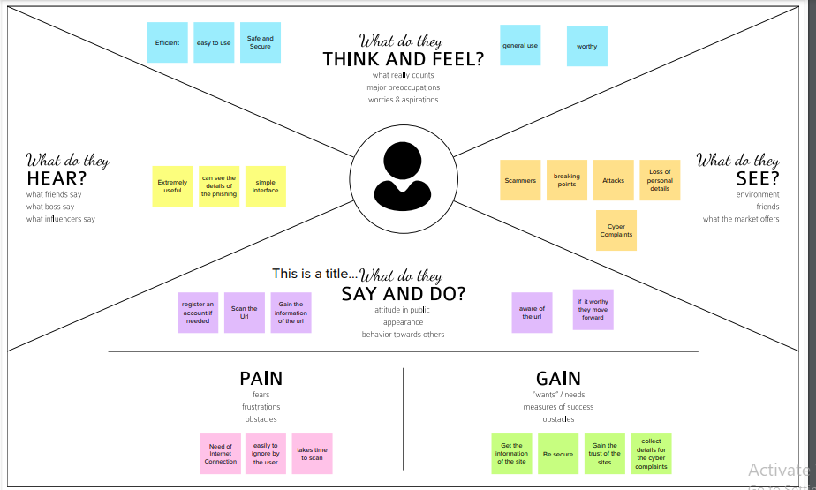

**2.3.2 PROPOSED SOLUTIONS**

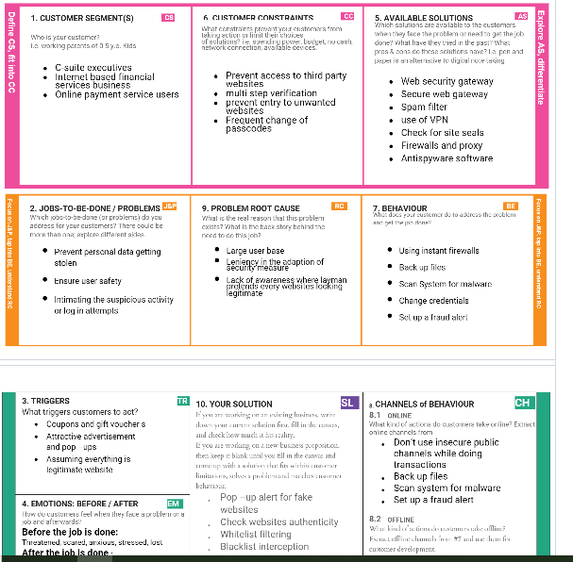

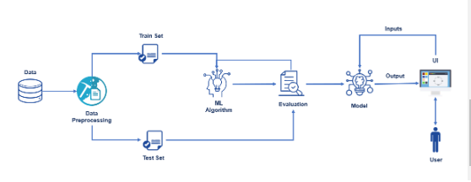

**Figure: technical architecture**

**4 REQUIREMENT ANALYSIS**

**4.1 FUNCTIONAL REQUIREMENT**

**Solution Architecture:**

Solution architecture is a complex process – with many sub-processes – that bridges the gap between business problems and technology solutions. Its goals are to:

Find the best tech solution to solve existing business problems. ● Describe the structure, characteristics, behavior, and other aspects of the software to project stakeholders. ● Define features, development phases, and solution requirements. ● Provide specifications according to which the solution is defined, managed, and delivered.

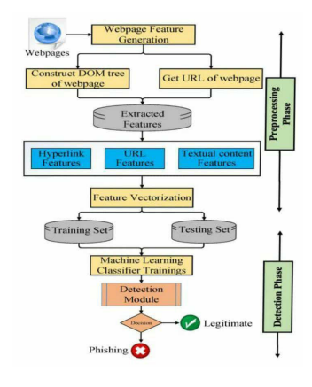

* 1. **NON FUNCTIONL REQUIRMENT**

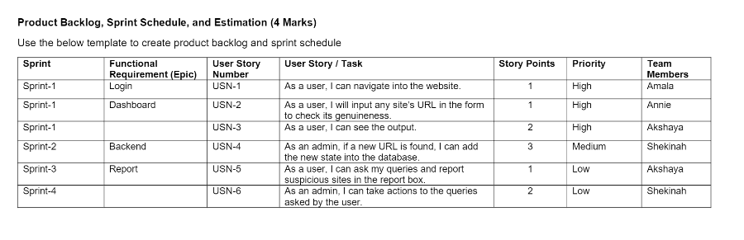

A characteristic of a quality SRS is that in addition to describing the functional requirements of a system, It will also provide detailed coverage of the non-functional requirements. In practice, this would entail detailed analysis of issues such as availability, security, usability and maintainability. However, as this document is only an outline specification, it does not contain the same degree of rig our that would normally be expected in a formal SRS. Therefore, the sections below should be seen as indicative rather than providing specific (l.e. testable) requirements.

1. **PROJECT DESIGN**

5.1 Data Flow Diagrams

5.2 Solution & Technical Architecture

5.3 User Stories

**5.1 DATA FLOW DIAGRAMS**

A Data Flow Diagram (DFD) is a traditional visual representation of the information flows within a system. A neat and clear DFD can depict the right amount of the system requirement graphically. It shows how data enters and leaves the system, w 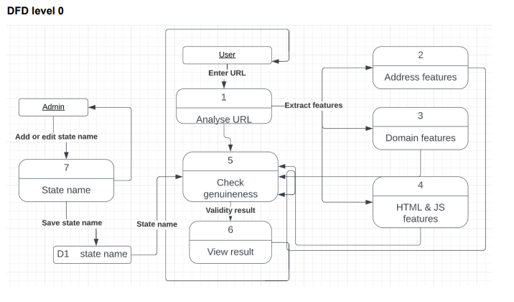

* 1. **SOLUTIONS & TECHNICAL ARCHITECTURE**

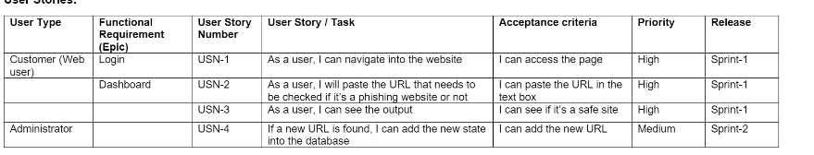

**PROJECT PLANNING & SCHEDULING**

**6.1 Sprint Planning & Estimation**

**6.2 sprint delivery Schedule**

**Project planning and scheduling**

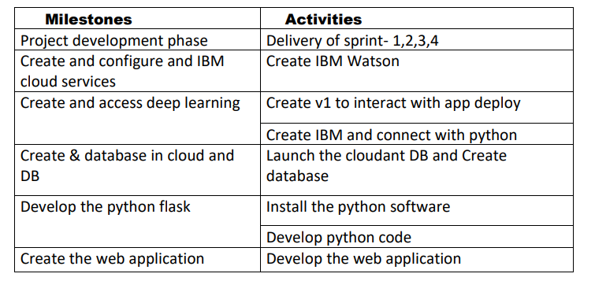

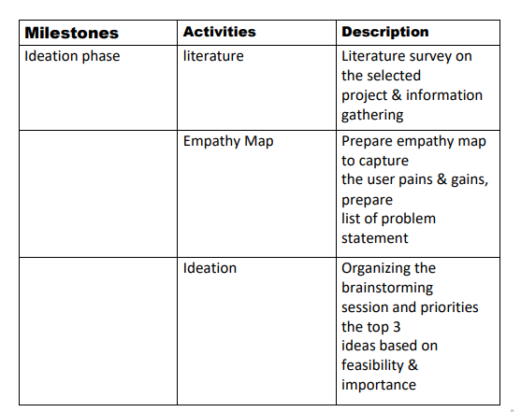

|  |  |  |  |  |
| --- | --- | --- | --- | --- |
| **sprint** | **Functional requirement** | **User story/task** | **Story priority points** | **Team member** |
| **Sprint 1** | Registration | User enter the details can register with details | 20 high | **Manikandan**  **Kalaiselvan**  **Goplakrishnan**  **Mathavan Ganth** |
| **Sprint 2** | Training of dataset | We can collect the dataset train the model using data | 20 high | **Manikandan**  **Kalaiselvan**  **Goplakrishnan**  **Mathavan Ganth** |
| **Sprint 3** | Prediction | Based on the model we can build the model | 20 high | **Manikandan**  **Kalaiselvan**  **Goplakrishnan**  **Mathavan Ganth** |

**RESULTS**

**Registration Page**

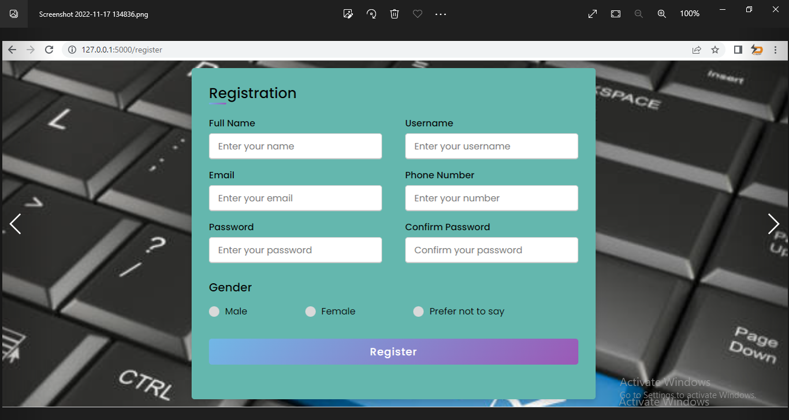

**Prediction result**

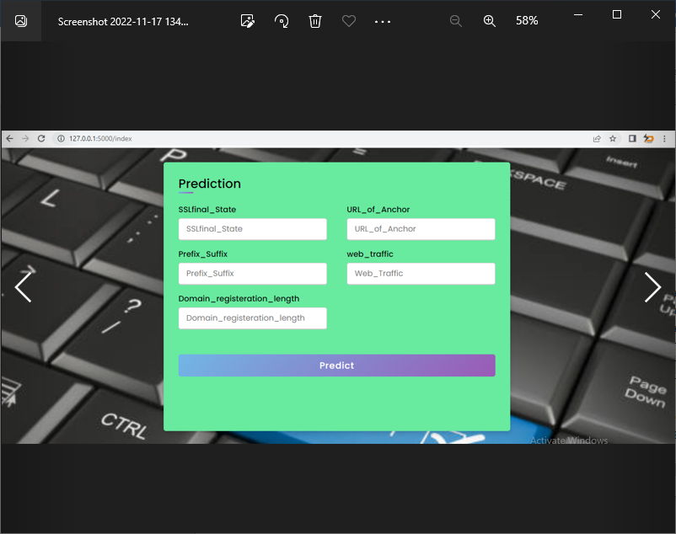

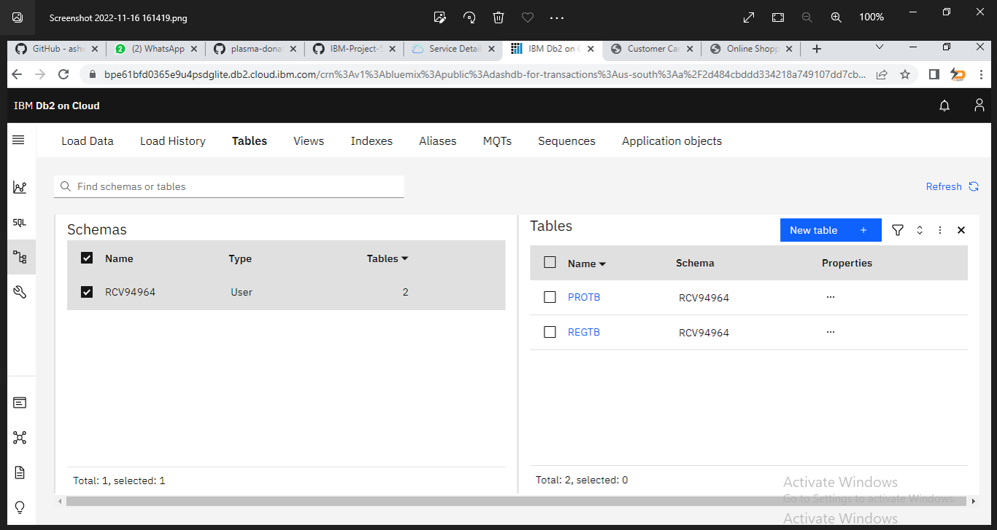

**TRAINING OF DATASET**

import numpy as np

import pandas as pd

**% loading data**

raw_data = pd.read_csv('100-legitimate-art.txt')

msg = 'http://www.emuck.com:3000/archive/egan.html'

msg = 'http://www.emuck.com:3000/archive/egan.html'

%websites

data = {'websites':[msg]}

raw_data = pd.DataFrame(data)

% raw_data['websites'].str.split("://").head()

seperation_of_protocol = raw_data['websites'].str.split("://",expand = Tru

e)

%seperation_of_protocol.head()

type(seperation_of_protocol)

% seperation_domain_name = seperation_of_protocol[1].str.split("/",1,expand = True)

def long_url(l):

    """This function is defined in order to differntiate website based on the length of the URL"""

    if len(l) < 54:

        return 0

    elif len(l) >= 54 and len(l) <= 75:

        return 2

    return 1

splitted_data['long_url'] = raw_data['websites'].apply(long_url)

def have_at_symbol(l):

    """This function is used to check whether the URL contains @ symbol or not"""

    if "@" in l:

        return 1

    return 0

% e have imported re module in the above feature. So need not to import again

splitted_data['shortening_service'] = raw_data['websites'].apply(shortening_service)

def shortening_service(url):

    match=re.search('bit\.ly|goo\.gl|shorte\.st|go2l\.ink|x\.co|ow\.ly|t\.co|tinyurl|tr\.im|is\.gd|cli\.gs|'

                    'yfrog\.com|migre\.me|ff\.im|tiny\.cc|url4\.eu|twit\.ac|su\.pr|twurl\.nl|snipurl\.com|'

                    'short\.to|BudURL\.com|ping\.fm|post\.ly|Just\.as|bkite\.com|snipr\.com|fic\.kr|loopt\.us|'

                    'doiop\.com|short\.ie|kl\.am|wp\.me|rubyurl\.com|om\.ly|to\.ly|bit\.do|t\.co|lnkd\.in|'

                    'db\.tt|qr\.ae|adf\.ly|goo\.gl|bitly\.com|cur\.lv|tinyurl\.com|ow\.ly|bit\.ly|ity\.im|'

                    'q\.gs|is\.gd|po\.st|bc\.vc|twitthis\.com|u\.to|j\.mp|buzurl\.com|cutt\.us|u\.bb|yourls\.org|'

                    'x\.co|prettylinkpro\.com|scrnch\.me|filoops\.info|vzturl\.com|qr\.net|1url\.com|tweez\.me|v\.gd|tr\.im|link\.zip\.net',url)

    if match:

        return 1

    else:

        return 0

**CODE**

**from flask import Flask,request, url_for, redirect, render_template import pickle**

**import numpy as np**

**app = Flask(__name__)**

**model=pickle.load(open('model.pkl','rb'))**

**@app.route('/')**

**def login():**

**return render_template("login.html")**

**@app.route('/register')**

**def register():**

**return render_template("register.html")**

**@app.route('/index')**

**def index(): return render_template("view.html")**

**@app.route('/predict',methods=['POST','GET'])**

**def predict():**

**int_features=[int(x) for x in request.form.values()]**

**final=[np.array(int_features)]**

**print(int_features)**

**print(final)**

**prediction=model.predict(final)[0]**

**if prediction==1:**

**return render_template('view.html',pred='This website is safe.'.format(prediction))**

**else:**

**return render_template('view.html',pred='This website is not safe.'.format(prediction))**

**if __name__ == '__main__':**

**app.run(debug=True)**

import socket

def statistical_report(url):

    hostname = url

    h = [(x.start(0), x.end(0)) for x in re.finditer('https://|http://|www.|https://www.|http://www.', hostname)]

    z = int(len(h))

    if z != 0:

        y = h[0][1]

        hostname = hostname[y:]

        h = [(x.start(0), x.end(0)) for x in re.finditer('/', hostname)]

        z = int(len(h))

        if z != 0:

            hostname = hostname[:h[0][0]]

    url_match=re.search('at\.ua|usa\.cc|baltazarpresentes\.com\.br|pe\.hu|esy\.es|hol\.es|sweddy\.com|myjino\.ru|96\.lt|ow\.ly',url)

    try:

        ip_address = socket.gethostbyname(hostname)

        ip_match=re.search('146\.112\.61\.108|213\.174\.157\.151|121\.50\.168\.88|192\.185\.217\.116|78\.46\.211\.158|181\.174\.165\.13|46\.242\.145\.103|121\.50\.168\.40|83\.125\.22\.219|46\.242\.145\.98|107\.151\.148\.44|107\.151\.148\.107|64\.70\.19\.203|199\.184\.144\.27|107\.151\.148\.108|107\.151\.148\.109|119\.28\.52\.61|54\.83\.43\.69|52\.69\.166\.231|216\.58\.192\.225|118\.184\.25\.86|67\.208\.74\.71|23\.253\.126\.58|104\.239\.157\.210|175\.126\.123\.219|141\.8\.224\.221|10\.10\.10\.10|43\.229\.108\.32|103\.232\.215\.140|69\.172\.201\.153|216\.218\.185\.162|54\.225\.104\.146|103\.243\.24\.98|199\.59\.243\.120|31\.170\.160\.61|213\.19\.128\.77|62\.113\.226\.131|208\.100\.26\.234|195\.16\.127\.102|195\.16\.127\.157|34\.196\.13\.28|103\.224\.212\.222|172\.217\.4\.225|54\.72\.9\.51|192\.64\.147\.141|198\.200\.56\.183|23\.253\.164\.103|52\.48\.191\.26|52\.214\.197\.72|87\.98\.255\.18|209\.99\.17\.27|216\.38\.62\.18|104\.130\.124\.96|47\.89\.58\.141|78\.46\.211\.158|54\.86\.225\.156|54\.82\.156\.19|37\.157\.192\.102|204\.11\.56\.48|110\.34\.231\.42',ip_address)

    except:

        return 1

    if url_match:

        return 1

    else:

        return 0

**HTML**

**<!DOCTYPE html>**

**<html lang="en" >**

**<head>**

**<meta charset="UTF-8">**

**<title>Classic Login Form Example</title>**

**<link href="https://fonts.googleapis.com/css?family=Assistant:400,700" rel="stylesheet">**

**<link rel="stylesheet" href="{{ url_for('static', filename='css/login.css') }}">**

**</head>**

**<body style="background-image: url('../static/images/360_F_119115529_mEnw3lGpLdlDkfLgRcVSbFRuVl6sMDty.jpg'); ">**

**<!-- partial:index.partial.html -->**

**<section class='login' id='login'>**

**<div class='head'>**

**<h1 class='company'>User Login</h1>**

**</div>**

**<p class='msg'>Welcome back</p>**

**<div class='form'>**

**<form>**

**<input type="text" placeholder='Username' class='text' id='username' required><br>**

**<input type="password" placeholder='••••••••••••••' class='password'><br>**

**<a href="/index" class='btn-login' >Login</a>**

**<a href="/register" class='btn-login' >Register</a>**

**</form>**

**</div>**

**</section>**

**</body>**

**</html>**

**<!DOCTYPE html>**

**<!-- Created By CodingLab - www.codinglabweb.com -->**

**<html lang="en" dir="ltr">**

**<head>**

**<meta charset="UTF-8">**

**<!---<title> Responsive Registration Form | CodingLab </title>--->**

**<link rel="stylesheet" href="{{ url_for('static', filename='css/style.css') }}">**

**<meta name="viewport" content="width=device-width, initial-scale=1.0">**

**</head>**

**<body style="background-image: url('../static/images/istockphoto-869283118-612x612.jpg'); background-repeat: no-repeat; background-size: cover;">**

**<div class="container" style="background-color: #68EA9F;">**

**<div class="title">Prediction</div>**

**<div class="content">**

**<form class="contact2-form validate-form" action="{{ url_for('predict')}}" method="post" >**

**<div class="user-details">**

**<div class="input-box">**

**<span class="details">SSLfinal_State</span>**

**<input class="input2" type="text" name="SSLfinal_State" required="required" placeholder="SSLfinal_State"/>**

**</div>**

**<div class="input-box">**

**<span class="details">URL_of_Anchor</span>**

**<input class="input2" type="text" name="URL_of_Anchor" required="required" placeholder="URL_of_Anchor"/>**

**</div>**

**<div class="input-box">**

**<span class="details">Prefix_Suffix</span>**

**<input class="input2" type="text" name="Prefix_Suffix" required="required" placeholder="Prefix_Suffix" />**

**</div>**

**<div class="input-box">**

**<span class="details">web_traffic</span>**

**<input class="input2" type="text" name="web_traffic" required="required" placeholder="Web_Traffic"/>**

**</div>**

**<div class="input-box">**

**<span class="details">Domain_registeration_length</span>**

**<input class="input2" type="text" name="Domain_registeration_length" required="required" placeholder="Domain_registeration_length"/>**

**</div>**

**</div>**

**<div class="button">**

**<input type="submit" value="Predict">**

**</div>**

**<br>**

**<br>**

**<h4 class="predict">{{ pred }}</h4>**

**</form>**

**</div>**

**</div>**

**</body></html>**

**ADVANTAGES**

* High Accuracy
* High Prediction Rate
* We can prevent the attacks
* High reliability

**DISADVANTAGES**

* High redutancy
* We can store less amount of data
* Reduced reliability

**CONCLUSION**

The phishing detection process using our model from the user prospective can be explained in the following steps:The end-user clicks on a link within an email or browses the internet.He will be directed to a website that could be legitimate or phishy. This website is basically the test data.A script written in PHP that is embedded within the browser starts processing to extract the features of the test data (current website) and saves them in a [data structure](https://www.sciencedirect.com/topics/computer-science/data-structure).Now, the intelligent model will be active within the browser to guess the type of the website based on rules learnt from historical websites (previous data collected). The rules of the [classifier](https://www.sciencedirect.com/topics/computer-science/classification-machine-learning) are utilised to predict the type of the test data based on features similarity.When the browsed website is identified as legitimate no action will be taken. On the other hand, when the website turned to be phishy, the user will be warned by the intelligent method that he is under risk.

**FUTURE WORK**

* **In future work the web phising system is implemented with new algorithm** High detection efficiency: To provide high detection efficiency, incorrect classification of benign sites as phishing (false-positive) should be minimal and correct classification of phishing sites (true-positive) should be high.
* Real-time detection: The prediction of the phishing detection approach must be provided before exposing the user's personal information on the phishing website.
* Target independent: Due to the features extracted from both URL and HTML the proposed approach can detect new phishing websites targeting any benign website (zero-day attack).
* Third-party independent: The feature set defined in our work are lightweight and client-side adaptable, which do not rely on third-party services such as blacklist/whitelist, Domain Name System (DNS) records, WHOIS record (domain age), search engine indexing, network traffic measures, etc. Though third-party services may raise the effectiveness of the detection approach, they might misclassify benign websites if a benign website is newly registered. Furthermore, the DNS database and domain age record may be poisoned and lead to false negative results (phishing to benign).

Hence, a light-weight technique is needed for phishing websites detection adaptable at client side. The major contributions in this paper are itemized as follows.

* We propose a phishing detection approach, which extracts efficient features from the URL and HTML of the given webpage without relying on third-party services. Thus, it can be adaptable at the client side and specify better privacy.
* We proposed eight novel features including URL character sequence features (F1), textual content character level (F2), various hyperlink features (F3, F4, F5, F6, F7, and F14) along with seven existing features adopted from the literature.
* We conducted extensive experiments using various machine learning algorithms to measure the efficiency of the proposed features. Evaluation results manifest that the proposed approach precisely identifies the legitimate websites as it has a high true negative rate and very less false positive rate.
* We release a real phishing webpage detection dataset to be used by other researchers on this topic.